# Freelance & Client Web Development (Oct 2021 – May 2022) Case Study

## Project overview

During the early part of my career I worked as a freelance web developer and digital consultant, designing and implementing custom websites and online stores for a variety of clients—from local businesses to national brands. The projects shared a common theme: helping clients establish a professional online presence, launch e‑commerce capabilities and integrate marketing tools.

Many of these sites were built on **WordPress**, an open‑source content management system. WordPress has grown from a simple blogging tool into the platform of choice for over 43 % of all sites on the web[[1]](https://wordpress.org/about/#:~:text=WordPress%20started%20in%202003%20when,all%20sites%20across%20the%20web). It runs on PHP and MySQL and is licensed under the GPLv2, allowing developers to modify and distribute the software freely[[1]](https://wordpress.org/about/#:~:text=WordPress%20started%20in%202003%20when,all%20sites%20across%20the%20web). Importantly, WordPress offers a straightforward “out of the box” experience for non‑technical users while allowing more tech‑savvy developers to customize it extensively[[2]](https://wordpress.org/about/#:~:text=People%20with%20a%20limited%20tech,customize%20it%20in%20remarkable%20ways). I took advantage of this flexibility to craft tailored themes, plugins and page templates.

## Typical responsibilities and tasks

* **End‑to‑end website builds.** Collaborated with clients to understand goals, designed user‑friendly layouts, and implemented responsive themes using WordPress and occasionally Shopify or custom frameworks. Built custom page templates, integrated third‑party plugins and optimized front‑end performance.
* **E‑commerce and membership functionality.** Added WooCommerce storefronts, subscription management and secure payment processing to client sites. Configured product catalogs, discounts and shipping options.
* **Content and SEO.** Worked with clients to structure content, implement metadata and optimize pages for search engines. Ensured websites were accessible, performant and mobile‑friendly.
* **Analytics and marketing integrations.** Deployed Google Tag Manager and Google Analytics to track site performance and marketing campaigns. Integrated email marketing platforms and social media pixels.
* **Maintenance and support.** Provided ongoing updates, security hardening and troubleshooting. Trained clients to manage content through the CMS.

## Technology stack

The freelance work spanned multiple technologies:

* **WordPress** – Customized themes, plugins and page templates using PHP, HTML, CSS and JavaScript. Leveraged WordPress’s open‑source nature to extend functionality[[3]](https://wordpress.org/about/#:~:text=WordPress%20started%20in%202003%20when,all%20sites%20across%20the%20web).
* **Shopify and WooCommerce** – Implemented e‑commerce stores with flexible product management and payment integrations.
* **Front‑end frameworks** – Used React or vanilla JavaScript for interactive components. Ensured cross‑browser compatibility and responsive design.
* **Analytics tools** – Implemented marketing tags via Google Tag Manager and configured Google Analytics 4 properties for comprehensive reporting.

## My role & contributions

* Acted as a full‑stack developer and consultant, guiding clients from concept to launch. Wrote clean, maintainable code and used version control systems (Git) to manage project history.
* Designed custom themes and templates that aligned with each client’s brand, applying UI/UX principles to improve usability and engagement.
* Integrated secure e‑commerce functionality and tested checkout flows to ensure smooth customer experiences.
* Set up analytics, SEO and marketing tools, empowering clients to measure the success of their sites and campaigns.
* Documented processes and trained clients on using CMS dashboards so they could maintain content independently.

## Client Project Screenshots

BungalowSavings.com – WooCommerce WordPress storefront. Responsible for backend upkeep, plugin stack, and custom UI styling. (Archived)

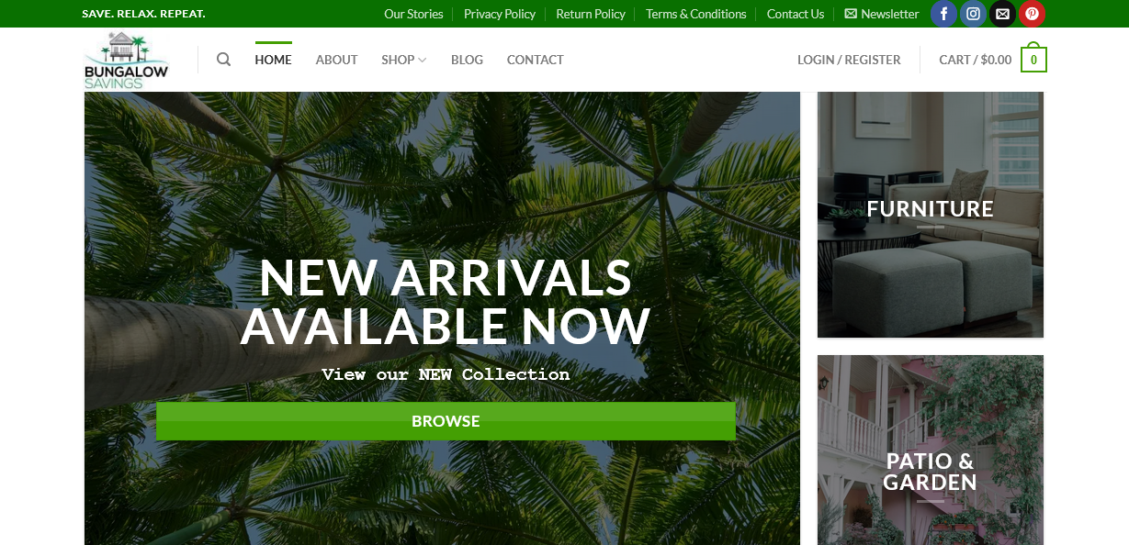

RenLasan.com – Elementor-based WordPress site for an independent YouTube vlogger. Delivered flexible content layout with built-in SEO enhancements. (Archived)

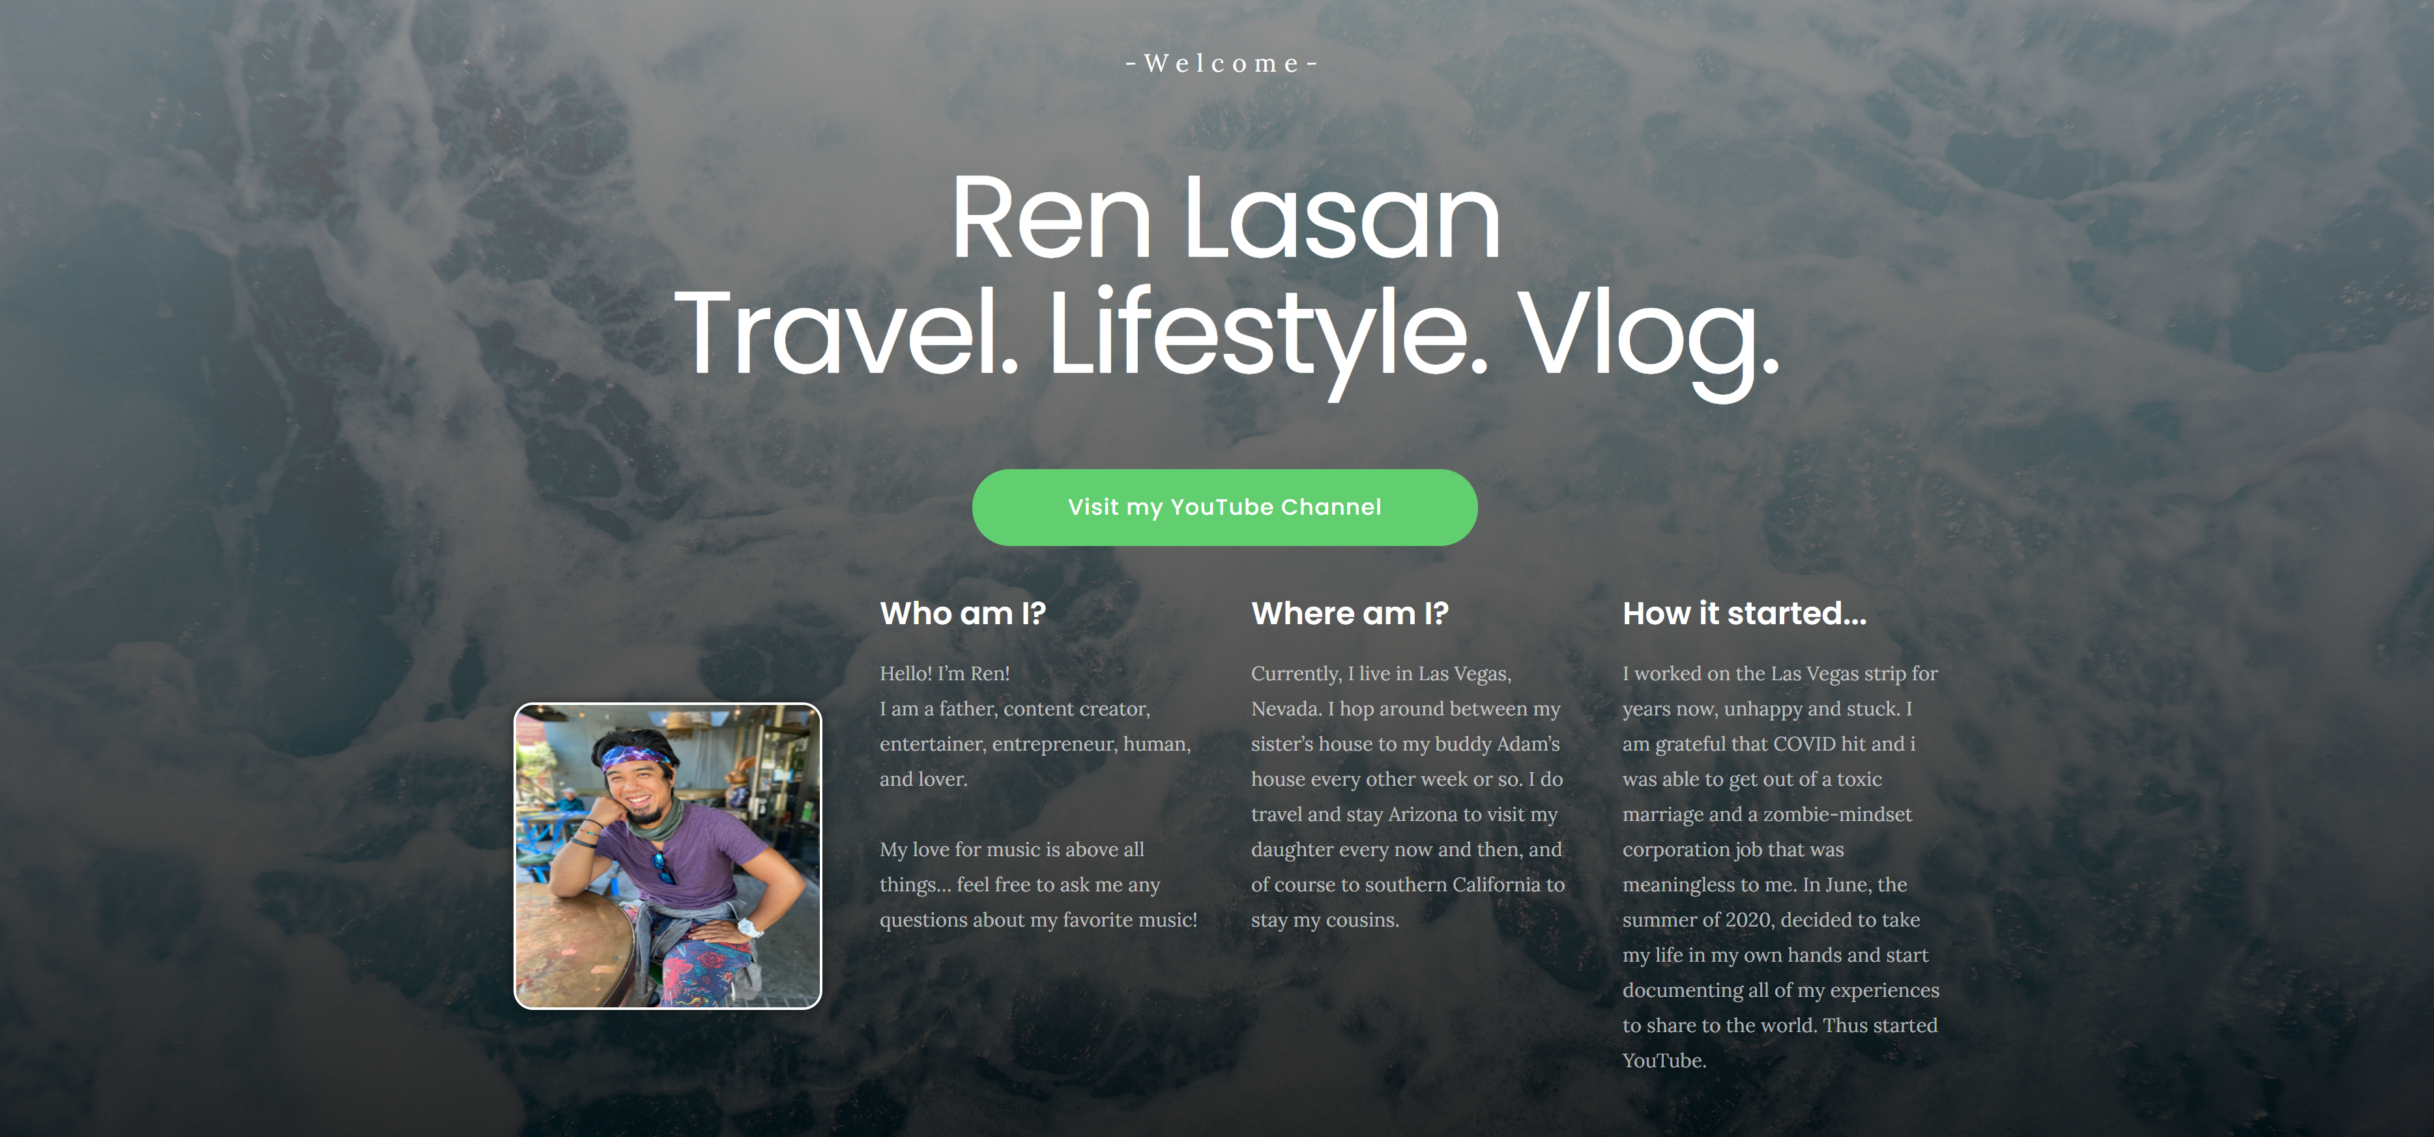

ExclusiveVIPTaxi.com – Multilingual landing page built with Bootstrap. Features user language toggle and geo-targeted metadata for SEO. (Archived)



MobileQubes.com – Custom WordPress site developed from Figma designs using Blocksy. Focused on mobile-first UX and performance optimization. (Archived)

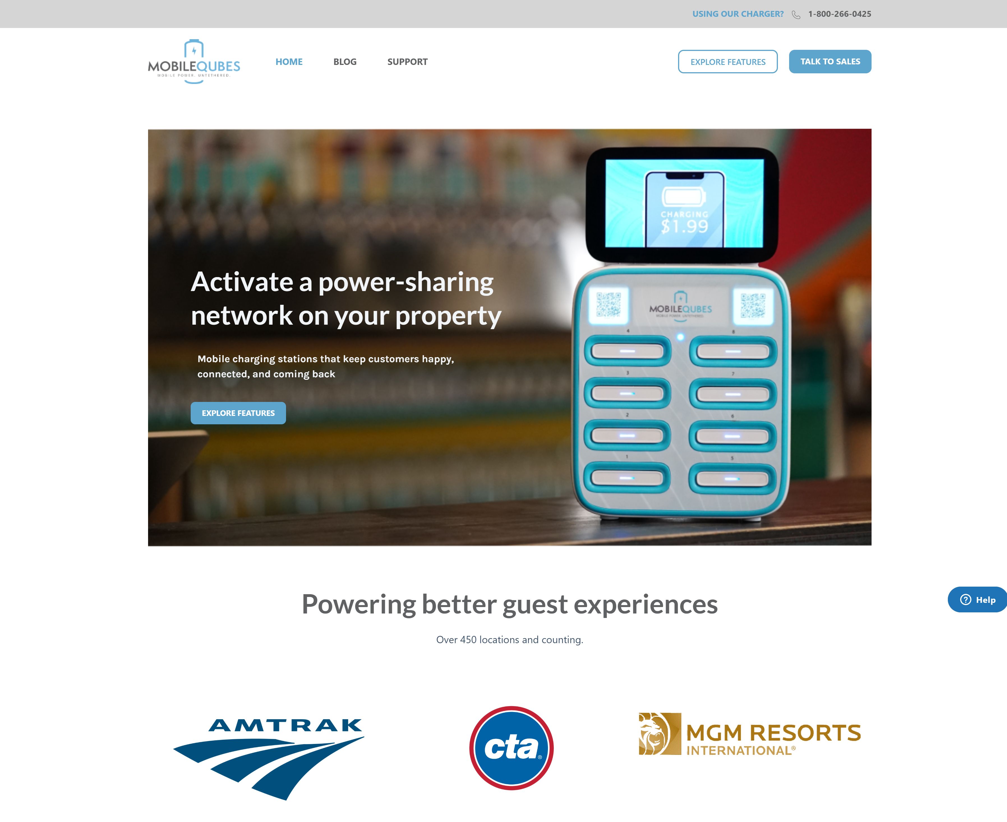

## Personal Project Screenshots

[Blackjack Game](https://github.com/maya-jade/blackjack-game) – A fully functional vanilla JavaScript game. Implements real-time score tracking and basic game logic.

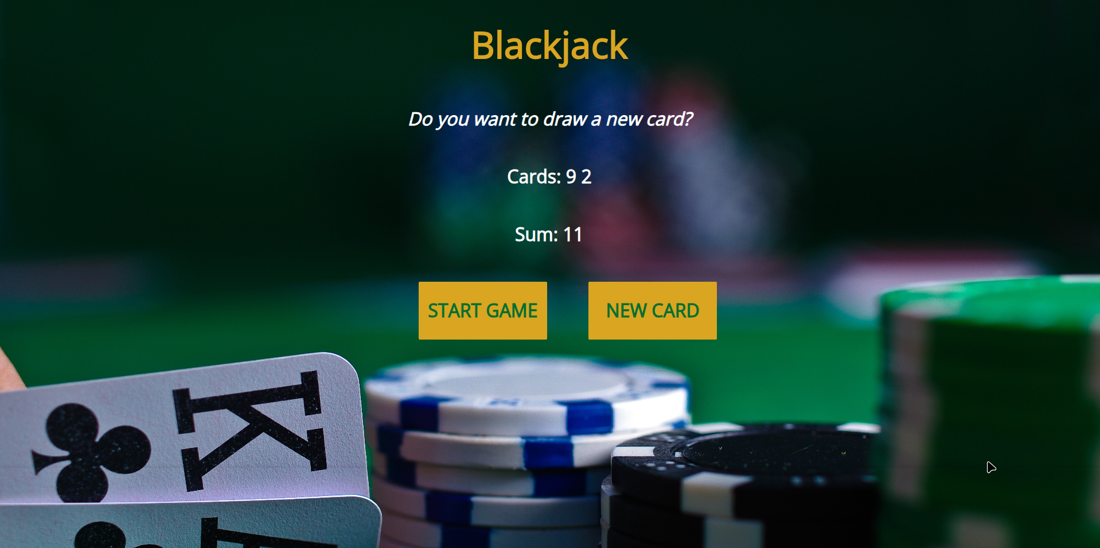

[Login Page](https://github.com/maya-jade/login-page) – Responsive login form with social button styling and accessible form controls using semantic HTML/CSS.



[HognoseQueen.com](https://github.com/maya-jade/hognose-queen-website) – A personal business site built to market and sell reptiles. Custom-built and optimized for small business sales.

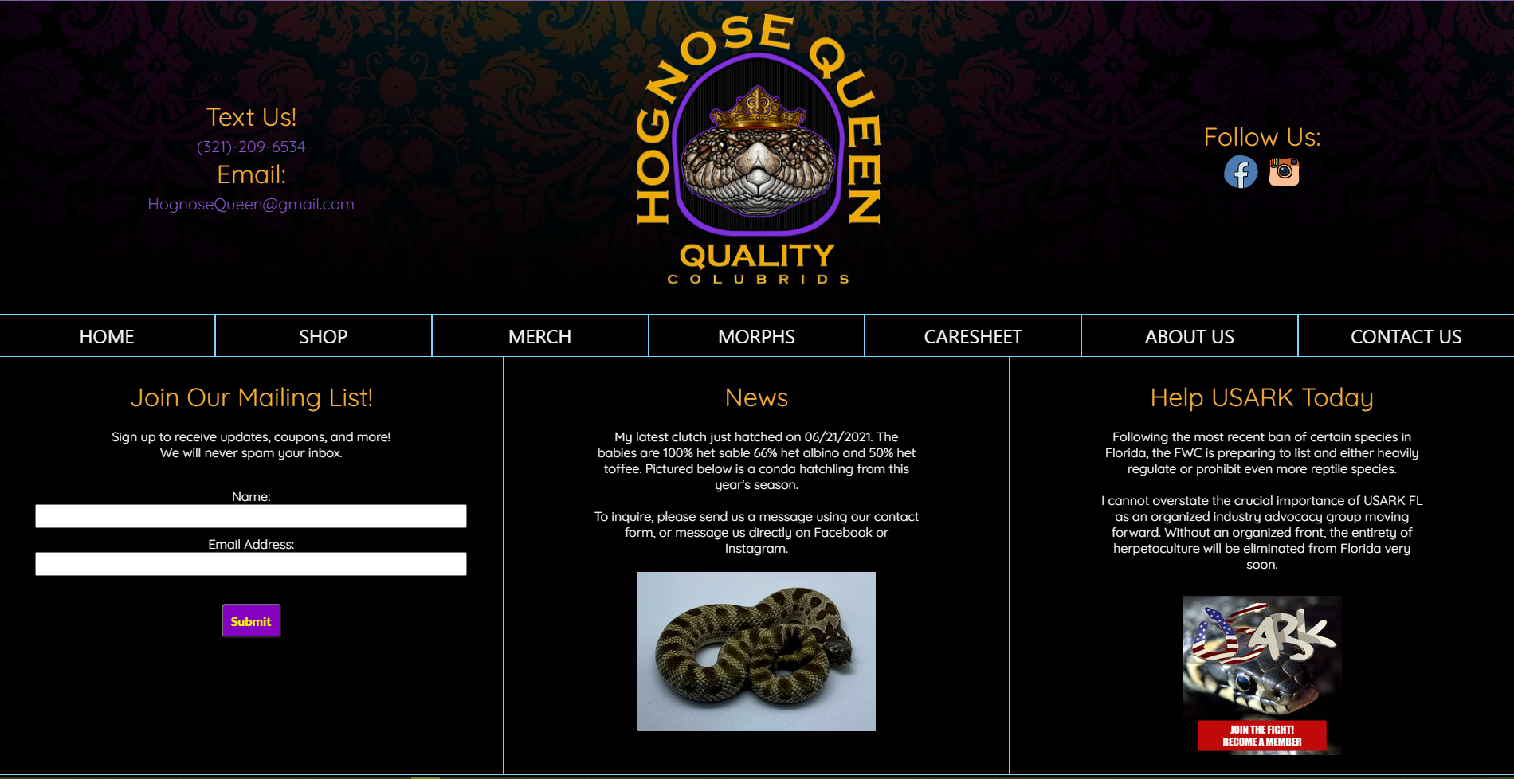

[Maya-Jade.dev](https://maya-jade.dev/) – A portfolio site built with hand-coded HTML and CSS, designed for performance and clarity. Deployed via GitHub Pages.



## Citations

[[1]](https://wordpress.org/about/#:~:text=WordPress%20started%20in%202003%20when,all%20sites%20across%20the%20web) [[2]](https://wordpress.org/about/#:~:text=People%20with%20a%20limited%20tech,customize%20it%20in%20remarkable%20ways) [[3]](https://wordpress.org/about/#:~:text=WordPress%20started%20in%202003%20when,all%20sites%20across%20the%20web) About – WordPress.org

<https://wordpress.org/about/>